Latchkey Gallery
173 Henry Street, New York, NY, 10002
(646) 213-9070
info@latchkeygallery.com
www.latchkey-gallery.com
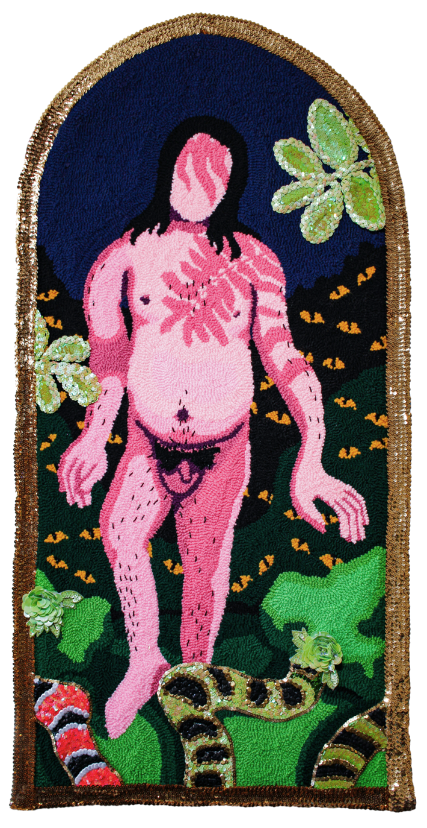
Guarida, 2024, Punch Needle, Yarn, Sequin, beads, 54 x 27 in

PRESS RELEASE
En la Guarida de las Monstras Divinas, Moises Salazar Tlatenchi
April 5 – May 5, 2024
Gallery Hours: Thurs - Sat: 12pm - 6pm & Sun: 12pm - 4pm
FOR IMMEDIATE RELEASE (New York, NY) - Latchkey Gallery is pleased to announce the opening of En la Guarida de las Monstras Divinas, a solo exhibition presenting new works by Moises Salazar Tlatenchi (b. Chicago, Illinois, 1996). The exhibition will be on view from April 5th, 2024 - May 5th, 2024, at 173 Henry Street and the opening reception on Friday, April 5th, from 6:00pm to 9:00pm.
En la Guarida de las Monstras Divinas pairs marginalized narratives of queer discovery, rejection, and acceptance, with popular narrative construction and ancient Aztec deities. The monomyth (Hero’s journey) overarches the three spaces in the exhibition, going from the watchful unknown, to the discovery and unification of self, and lastly joining and fostering communities.
The initial space is dedicated to self-discovery. An experience laced with beauty, vulnerability and understandings of judgment, eyes and darker colors lace the arched paintings, and snakes run throughout the space. The serpent is a representation of the Aztec deity Quetzalcoatl, associated with themes of creation. Guardia, a painting in this collection, uses dark blue and hot pink tufting to characterize and shade the figure, who stands naked. The fearful quiet present in these works alludes to the stereotypical ‘call to adventure’, stepping into a cold and unforgiving space of change and upheaval.
A mural of two uniting figures centers the exhibition, and references the natural fusion and zoomorphic reference present in Aztec deities. This large and overarching structure of understanding the world comes back to the experience in varying ideas of oneself. Salazar uses this medium to align the abyssal experience of revelation and rebirth in a larger than life and supernatural context, whilst also acknowledging heritage. This style plays into the dramatic, while also illustrating an irreversible understanding of self. Additionally, recurrently present in this peice is multi-color tufting, simultaneously creating shade, composition, and texture.
Lastly, the wanderer enters a space of community, tied to the narrative idea of the ‘gift of the goddess’. Salazar portrays ideas of chosen family as the biblical Garden of Eden, and ties paradisiacal themes into use of soft colors, reorienting the myth to extend its arms to those who grow into themselves. The figure grows as well, going from scared and unsure to a surrounded mother of the next generation.
Salazar’s paintings involve breaking down ideas of material and self, using varying colors and textures to compose self-influenced portraiture. Adorned with unique and contrasting use of tufting, sequins and extensive hand-placed beads, representation of these faceless figures creates stability and surface for an identity that is not always welcome, and allows the audience to align themselves with scenes usually kept behind closed doors.
A catalogue with an essay by Laura Suarez Rodriguez will accompany the exhibition.
ABOUT THE ARTIST
Moises Salazar Tlatenchi (B. 1996, Chicago, IL) is a non-binary artist based in Chicago, Illinois. Tlatenchi holds a BFA from the School of the Art Institute of Chicago. Tlatenchi’s work has been exhibited nationally and internationally at WOAW Gallery, Salon ACME 8, the Museum of Contemporary Art Chicago, NADA, National Museum of Mexican Art, and the Chicago Cultural Center.
Tlatenchi has been focused on conceptual and installation-based work. Tlatenchi’s presentation Let’s get Physical facilitated by Filo Sofi Arts was included in HEARSAY:HERESY Spring Break Art Show to much critical acclaim. A Finalist of The QUEERART PRIZE, Salazar’s work has been featured in publications such as The Hispanic Executive, artnet, HYPERALLERGIC, and THE LATINX PROJECT. Tlatenchi has participated in the The Hyde Park Art Center Residency and is a recipient of LuminArts Foundation Arts Fellowship, 3Arts Make a Wave Grant and is a Fire Island Artist Residency recipient. Most recently Tlatenchi has been named one of the 2023 Breakout Artists : Chicago’s Next Generation of Image Makers.

For more information, please contact info@latchkeygallery.com

